December 1, 2015

Dear Growing and Knowing Academy Families,
I would like to share some exciting news! You may have noticed a star window cling on our door – this means that we’re participating in Grow NJ Kids, New Jersey’s quality rating and improvement system (QRIS) administered by the Departments of Children and Families, Education, Health, and Human Services. As a Grow NJ Kids participant, we are showing our commitment to offering high-quality child care and getting your child ready for school.
You might be wondering – what is a QRIS? A QRIS is a process for supporting and strengthening care provided by child care and early learning programs. More than 40 states including New Jersey have a statewide QRIS. New Jersey began implementing our system in April 2013. Similar to a hotel rating, participating child care and early learning programs are assigned a star rating based on observed quality. Observed quality means that Grow NJ Kids staff will be coming into our program to work with us in reviewing quality standards. Working together, we will review things such as our activities and curriculum, how we work with families and how we interact with children. As a Grow NJ Kids participant, we will get resources to help our program improve - including coaching, training, and scholarships.
Family involvement is an important part of Grow NJ Kids. You can help support our participation by asking questions and staying involved. We will share our rating once we receive it and provide more information as needed.
If you still have questions or want more information about Grow NJ Kids, please visit their website at www.GrowNJKids.com. And don’t forget to look for our star window cling!
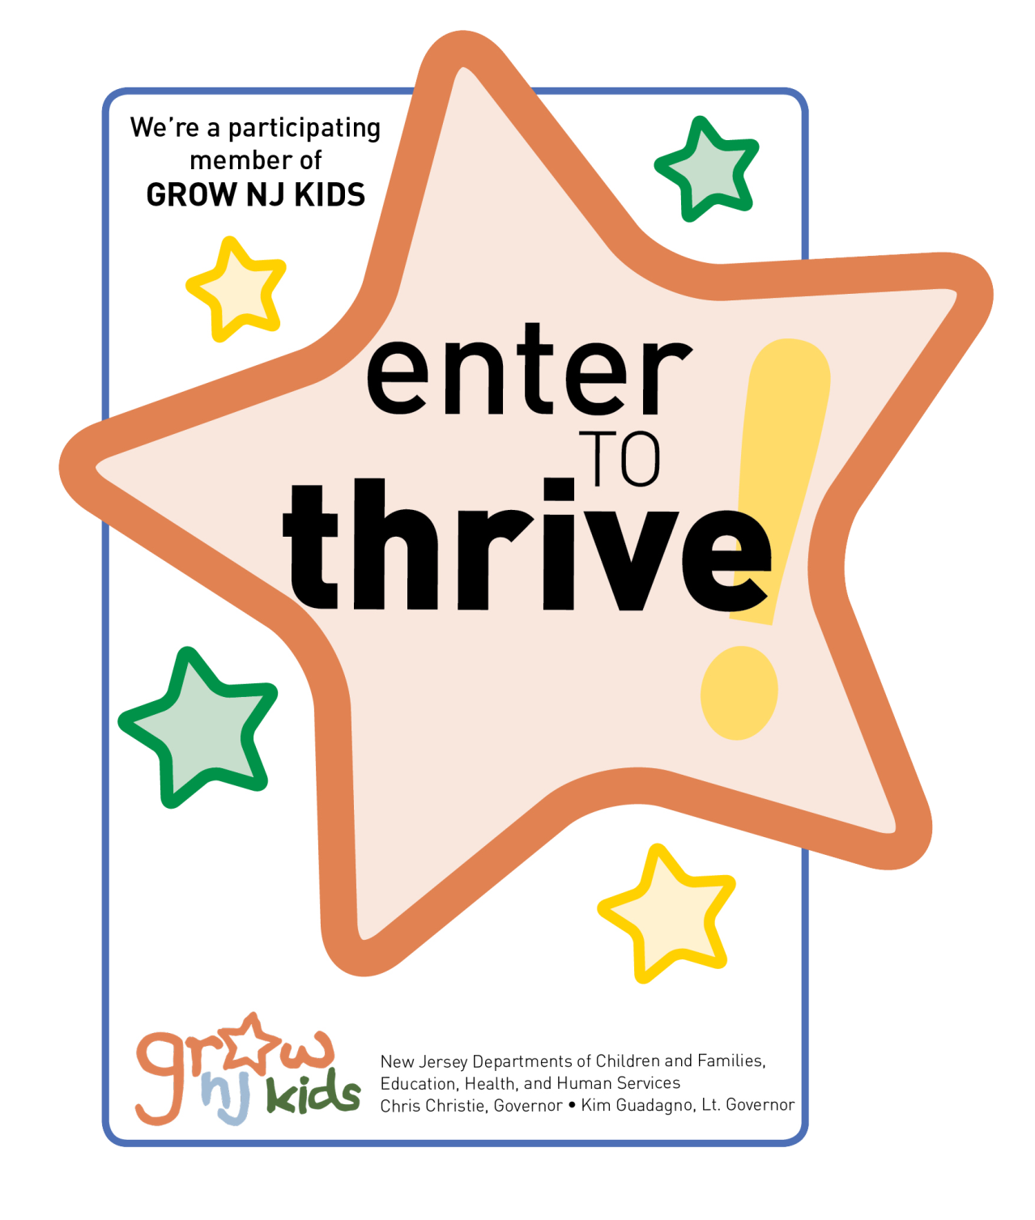

Thank you.

Gail Van Eeuwen
Owner/Director

Grow NJ Kids - Helping New Jersey’s Youngest Kids Thrive

