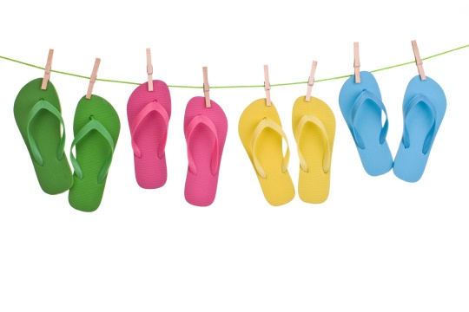
Summer Camp - July 2016
SUNDAY | MONDAY | TUESDAY | WEDNESDAY | THURSDAY | FRIDAY | SATURDAY
THEME: |  |  |  |  |  | 1
2 THEME:  Summer Fun | 3  4th of July  Break  School Closed! | 4  4th of July  Break  School Closed! | 5  Fourth of July Scavenger Hunt | 6  Art Class | 7  My Summer Bucket List | 8
9 THEME:  Water Fun!! | 10  At the  Car Wash! | 11  Ready, set,  Water Races!! | 12  Tie, Dye  & Pizza for Lunch! | 13  Water Gun fun! | 14  Newton Pool Field Trip | 15
16 THEME:  Fun in the Sun | 17  Shadow Art | 18  Let’s have a “fan” of applause | 19  Art Class | 20  Billy Beez Field Trip | 21  Chalk Figures Fun! | 22
23 THEME:  Water Sports | 24  Sponge Darts & Dodgeball | 25  Water Pinata | 26  Pizza &  Ice Cream Field Trip | 27  Water Balloon Basketball | 28  Foam  Twister | 29

